实验1 组合逻辑电路设计
一、实验目的
- 掌握组合逻辑电路的设计方法和步骤，实现译码器、编码器等基本组合逻辑电路。
- 掌握全加器的设计方法和原理，在1位全加器基础上实现1个4位串行进位加法器。
- 掌握多路选择器的应用。
二、实验环境
Vivado开发工具、ModelSim仿真软件。
三、设计任务与要求
1. 译码器实验
用Verilog HDL实现3-8译码器芯片74LS138，并进行仿真测试。
2. 编码器实验
用Verilog HDL实现8-3优先编码器芯片74LS148，并进行仿真测试。
3. 加法器实验
（1）用Verilog HDL实现1位全加器。
（2）在此基础上，用Verilog HDL实现4位串行进位加法器，并进行仿真测试。
4. 多路选择器的应用
用Verilog HDL实现1位ALU电路，其功能如下表所示，要求进行仿真测试。
1位ALU功能表
S3 | S2 | S1 | 功能
0 | 0 | 0 | A加B
0 | 0 | 1 | A减B
0 | 1 | 0 | A和B相与
0 | 1 | 1 | A和B相或
1 | 0 | 0 | A异或非B
1 | 0 | 1 | A非
1 | 1 | 0 | A
1 | 1 | 1 | B非
四、实验内容与步骤
1. 译码器
(a) 工作原理
74LS138为3线-8线低有效译码器。设计以G1为高有效使能、G2A_n和G2B_n为低有效使能；当使能条件满足时，由C、B、A组成3位地址，仅对应的一路Y_n输出为0，其余输出为1；当任一使能无效时，所有Y_n保持高电平。实现中将使能逻辑与地址译码组合展开，输出符合74LS138低有效端口语义。

(b) Verilog源程序
`timescale 1ns / 1ps
// 3-8译码器 74LS138
// 输入：A、B、C，其中 A 为最低位，C 为最高位
// 使能：G1 高有效，G2A_n 和 G2B_n 低有效
// 输出：Y_n[7:0] 低电平有效
//
// 当使能有效时：
// CBA = 000 -> Y0_n = 0
// CBA = 001 -> Y1_n = 0
// ...
// CBA = 111 -> Y7_n = 0
//
// 当使能无效时，所有输出均为 1
module decoder_74ls138 (
input wire G1,
input wire G2A_n,
input wire G2B_n,
input wire A,
input wire B,
input wire C,
output reg [7:0] Y_n
);
wire enable;
assign enable = G1 & (~G2A_n) & (~G2B_n);
always @(*) begin
if (enable == 1'b0) begin
Y_n = 8'b1111_1111;
end
else begin
case ({C, B, A})
3'b000: Y_n = 8'b1111_1110; // Y0_n = 0
3'b001: Y_n = 8'b1111_1101; // Y1_n = 0
3'b010: Y_n = 8'b1111_1011; // Y2_n = 0
3'b011: Y_n = 8'b1111_0111; // Y3_n = 0
3'b100: Y_n = 8'b1110_1111; // Y4_n = 0
3'b101: Y_n = 8'b1101_1111; // Y5_n = 0
3'b110: Y_n = 8'b1011_1111; // Y6_n = 0
3'b111: Y_n = 8'b0111_1111; // Y7_n = 0
default: Y_n = 8'b1111_1111;
endcase
end
end
endmodule

(c) RTL视图
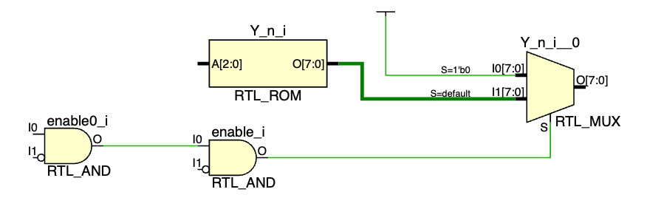

(d) ModelSim源程序
文件：lab1/task1/sim/tb_decoder_74ls138.v
`timescale 1ns / 1ps
module tb_decoder_74ls138;
reg G1;
reg G2A_n;
reg G2B_n;
reg [2:0] addr;
wire A;
wire B;
wire C;
wire [7:0] Y_n;
integer i;
integer error_count;
reg [7:0] expected;
assign A = addr[0];
assign B = addr[1];
assign C = addr[2];
decoder_74ls138 uut (
.G1(G1),
.G2A_n(G2A_n),
.G2B_n(G2B_n),
.A(A),
.B(B),
.C(C),
.Y_n(Y_n)
);
task check_result;
input [7:0] exp;
begin
#1;
if (Y_n !== exp) begin
$display("ERROR at time %0t ns: G1=%b, G2A_n=%b, G2B_n=%b, CBA=%b, Y_n=%b, expected=%b",
$time, G1, G2A_n, G2B_n, addr, Y_n, exp);
error_count = error_count + 1;
end
else begin
$display("PASS at time %0t ns: G1=%b, G2A_n=%b, G2B_n=%b, CBA=%b, Y_n=%b",
$time, G1, G2A_n, G2B_n, addr, Y_n);
end
end
endtask
initial begin
error_count = 0;
G1 = 1'b0;
G2A_n = 1'b0;
G2B_n = 1'b0;
addr = 3'b000;
#10;
// 测试使能无效情况 1：G1 = 0
G1 = 1'b0;
G2A_n = 1'b0;
G2B_n = 1'b0;
addr = 3'b000;
#10;
check_result(8'b1111_1111);
// 测试使能无效情况 2：G2A_n = 1
G1 = 1'b1;
G2A_n = 1'b1;
G2B_n = 1'b0;
addr = 3'b011;
#10;
check_result(8'b1111_1111);
// 测试使能无效情况 3：G2B_n = 1
G1 = 1'b1;
G2A_n = 1'b0;
G2B_n = 1'b1;
addr = 3'b101;
#10;
check_result(8'b1111_1111);
// 测试使能有效情况下的 8 种输入组合
G1 = 1'b1;
G2A_n = 1'b0;
G2B_n = 1'b0;
for (i = 0; i < 8; i = i + 1) begin
addr = i[2:0];
expected = ~(8'b0000_0001 << i);
#10;
check_result(expected);
end
if (error_count == 0) begin
$display("========================================");
$display("Simulation PASSED. No errors found.");
$display("========================================");
end
else begin
$display("========================================");
$display("Simulation FAILED. Error count = %0d", error_count);
$display("========================================");
end
#10;
$stop;
end
endmodule
仿真脚本：lab1/task1/sim/run.do
transcript on
if {[file exists work]} {
vdel -lib work -all
}
vlib work
vmap work work
vlog -work work ../src/decoder_74ls138.v
vlog -work work tb_decoder_74ls138.v
vsim -voptargs=+acc work.tb_decoder_74ls138
do wave.do
run -all

(e) ModelSim仿真结果

2. 编码器
(a) 工作原理
74LS148为8线-3线优先编码器，输入I_n、输出A_n以及扩展信号GS_n/EO_n均采用低有效语义。EI_n无效时编码器禁止，输出保持无有效编码状态；EI_n有效且存在低有效输入时，I7优先级最高，输出对应低有效编码，同时GS_n表明存在有效输入，EO_n用于级联扩展。

(b) Verilog源程序
`timescale 1ns / 1ps
// 任务2：8-3 优先编码器 74LS148
// 用 Verilog HDL 实现 8-3 优先编码器芯片 74LS148，并进行仿真测试。
module encoder_74ls148 (
input wire EI_n,
input wire [7:0] I_n,
output reg [2:0] A_n,
output reg GS_n,
output reg EO_n
);
always @(*) begin
if (EI_n) begin
A_n = 3'b111;
GS_n = 1'b1;
EO_n = 1'b1;
end else begin
EO_n = 1'b1;
GS_n = 1'b0;
casex (I_n)
8'b0xxx_xxxx: A_n = 3'b000; // I7 has highest priority.
8'b10xx_xxxx: A_n = 3'b001;
8'b110x_xxxx: A_n = 3'b010;
8'b1110_xxxx: A_n = 3'b011;
8'b1111_0xxx: A_n = 3'b100;
8'b1111_10xx: A_n = 3'b101;
8'b1111_110x: A_n = 3'b110;
8'b1111_1110: A_n = 3'b111;
default: begin
A_n = 3'b111;
GS_n = 1'b1;
EO_n = 1'b0;
end
endcase
end
end
endmodule

(c) RTL视图
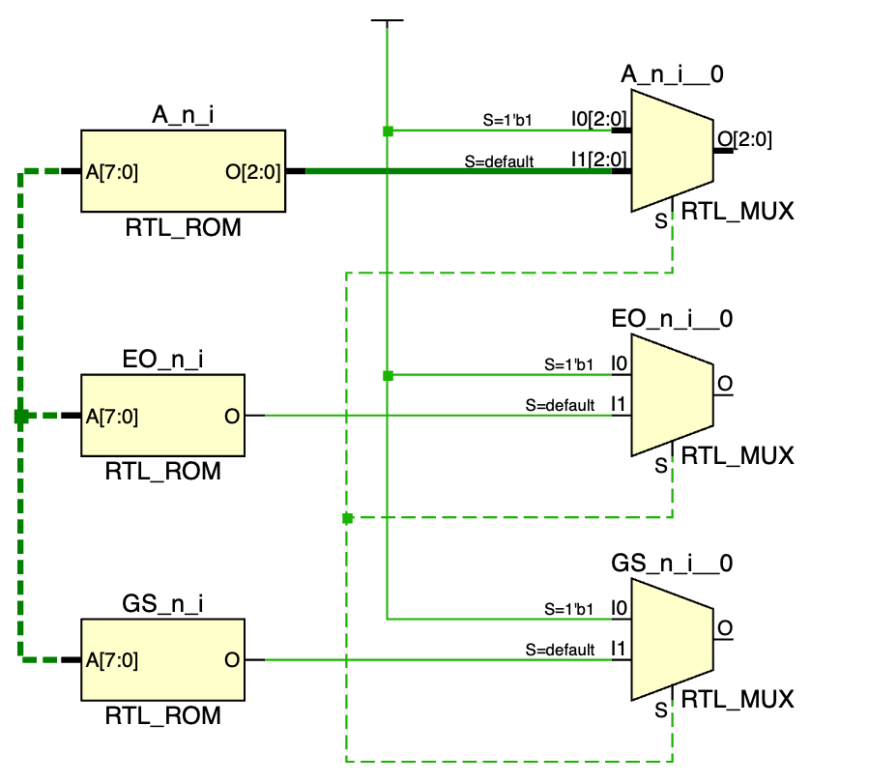

(d) ModelSim源程序
文件：lab1/task2/sim/tb_encoder_74ls148.v
`timescale 1ns / 1ps
// Self-checking testbench for 任务2：8-3 优先编码器 74LS148.
module tb_encoder_74ls148;
reg EI_n;
reg [7:0] I_n;
wire [2:0] A_n;
wire GS_n;
wire EO_n;
integer i;
integer error_count;
encoder_74ls148 uut (
.EI_n(EI_n),
.I_n(I_n),
.A_n(A_n),
.GS_n(GS_n),
.EO_n(EO_n)
);
task check_result;
input [2:0] exp_a_n;
input exp_gs_n;
input exp_eo_n;
begin
#1;
if (A_n !== exp_a_n || GS_n !== exp_gs_n || EO_n !== exp_eo_n) begin
$display("ERROR time=%0t EI_n=%b I_n=%b A_n=%b GS_n=%b EO_n=%b expected A_n=%b GS_n=%b EO_n=%b",
$time, EI_n, I_n, A_n, GS_n, EO_n,
exp_a_n, exp_gs_n, exp_eo_n);
error_count = error_count + 1;
end else begin
$display("PASS time=%0t EI_n=%b I_n=%b A_n=%b GS_n=%b EO_n=%b",
$time, EI_n, I_n, A_n, GS_n, EO_n);
end
end
endtask
initial begin
error_count = 0;
EI_n = 1'b1; I_n = 8'b0000_0000; #10;
check_result(3'b111, 1'b1, 1'b1);
EI_n = 1'b0; I_n = 8'b1111_1111; #10;
check_result(3'b111, 1'b1, 1'b0);
for (i = 0; i < 8; i = i + 1) begin
EI_n = 1'b0;
I_n = 8'b1111_1111;
I_n[i] = 1'b0;
#10;
check_result(~i[2:0], 1'b0, 1'b1);
end
EI_n = 1'b0; I_n = 8'b0110_1010; #10;
check_result(3'b000, 1'b0, 1'b1);
EI_n = 1'b0; I_n = 8'b1110_0101; #10;
check_result(3'b011, 1'b0, 1'b1);
if (error_count == 0) begin
$display("========================================");
$display("Simulation PASSED. No errors found.");
$display("========================================");
end else begin
$display("========================================");
$display("Simulation FAILED. Error count = %0d", error_count);
$display("========================================");
end
$finish;
end
endmodule
仿真脚本：lab1/task2/sim/run.do
transcript on
onbreak {resume}
onerror {quit -code 1}
set sim_dir [file normalize [pwd]]
set root_dir [file normalize [file join $sim_dir ".."]]
set top_module "encoder_74ls148"
set sim_top "tb_encoder_74ls148"
cd $sim_dir
if {[file exists work]} {
vdel -lib work -all
}
vlib work
vmap work work
set src_files [lsort [glob -nocomplain [file join $root_dir "src" "*.v"]]]
set tb_files [lsort [glob -nocomplain [file join $sim_dir "*.v"]]]
if {[llength $src_files] == 0} {
puts "ERROR: No RTL source files found in [file join $root_dir src]"
quit -code 1
}
if {[llength $tb_files] == 0} {
puts "ERROR: No testbench files found in $sim_dir"
quit -code 1
}
puts "========================================"
puts "Compile RTL sources"
puts "========================================"
foreach file $src_files {
puts "vlog $file"
vlog -work work $file
}
puts "========================================"
puts "Compile simulation sources"
puts "========================================"
foreach file $tb_files {
puts "vlog $file"
vlog -work work $file
}
puts "========================================"
puts "Start simulation: work.$sim_top"
puts "========================================"
vsim -voptargs=+acc work.$sim_top
onfinish stop
if {[batch_mode]} {
log -r /*
} elseif {[file exists [file join $sim_dir "wave.do"]]} {
do [file join $sim_dir "wave.do"]
} else {
log -r /*
add wave -r /*
}
run -all
set error_count_value ""
if {![catch {examine -radix decimal /$sim_top/error_count} error_count_value]} {
puts "Self-check error_count = $error_count_value"
if {$error_count_value != 0} {
puts "ERROR: Self-checking testbench reported failures."
quit -code 1
}
}
puts "========================================"
puts "ModelSim flow finished."
puts "Top module: $top_module"
puts "Simulation top: $sim_top"
puts "========================================"

(e) ModelSim仿真结果

3. 加法器
(a) 工作原理
1位全加器按sum=a^b^cin、cout=ab+acin+bcin生成本位和与进位；4位串行进位加法器由4个1位全加器级联构成，低位cout作为相邻高位cin，最终输出4位sum和最高位cout。

(b) Verilog源程序
`timescale 1ns / 1ps
// 任务3：1 位全加器与 4 位串行进位加法器
// 用 Verilog HDL 实现 1 位全加器，并在此基础上实现 4 位串行进位加法器，进行仿真测试。
module full_adder_1bit (
input wire a,
input wire b,
input wire cin,
output wire sum,
output wire cout
);
assign sum = a ^ b ^ cin;
assign cout = (a & b) | (a & cin) | (b & cin);
endmodule
module adder_4bit (
input wire [3:0] a,
input wire [3:0] b,
input wire cin,
output wire [3:0] sum,
output wire cout
);
wire c1;
wire c2;
wire c3;
full_adder_1bit u0 (.a(a[0]), .b(b[0]), .cin(cin), .sum(sum[0]), .cout(c1));
full_adder_1bit u1 (.a(a[1]), .b(b[1]), .cin(c1), .sum(sum[1]), .cout(c2));
full_adder_1bit u2 (.a(a[2]), .b(b[2]), .cin(c2), .sum(sum[2]), .cout(c3));
full_adder_1bit u3 (.a(a[3]), .b(b[3]), .cin(c3), .sum(sum[3]), .cout(cout));
endmodule

(c) RTL视图
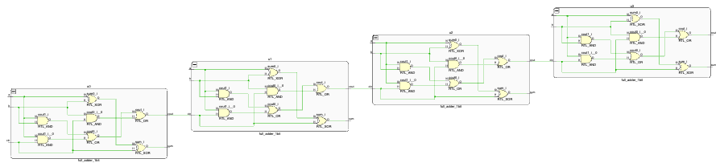

(d) ModelSim源程序
文件：lab1/task3/sim/tb_adder_4bit.v
`timescale 1ns / 1ps
// Self-checking testbench for 任务3：1 位全加器与 4 位串行进位加法器.
module tb_adder_4bit;
reg [3:0] a;
reg [3:0] b;
reg cin;
wire [3:0] sum;
wire cout;
integer ai;
integer bi;
integer ci;
integer error_count;
reg [4:0] expected;
adder_4bit uut (
.a(a),
.b(b),
.cin(cin),
.sum(sum),
.cout(cout)
);
task check_result;
input [4:0] exp;
begin
#1;
if ({cout, sum} !== exp) begin
$display("ERROR time=%0t a=%h b=%h cin=%b sum=%h cout=%b expected=%h",
$time, a, b, cin, sum, cout, exp);
error_count = error_count + 1;
end else begin
$display("PASS time=%0t a=%h b=%h cin=%b result=%h",
$time, a, b, cin, {cout, sum});
end
end
endtask
initial begin
error_count = 0;
for (ai = 0; ai < 16; ai = ai + 1) begin
for (bi = 0; bi < 16; bi = bi + 1) begin
for (ci = 0; ci < 2; ci = ci + 1) begin
a = ai[3:0];
b = bi[3:0];
cin = ci[0];
expected = ai + bi + ci;
#10; check_result(expected);
end
end
end
if (error_count == 0) begin
$display("========================================");
$display("Simulation PASSED. No errors found.");
$display("========================================");
end else begin
$display("========================================");
$display("Simulation FAILED. Error count = %0d", error_count);
$display("========================================");
end
$finish;
end
endmodule
仿真脚本：lab1/task3/sim/run.do

transcript on
onbreak {resume}
onerror {quit -code 1}
set sim_dir [file normalize [pwd]]
set root_dir [file normalize [file join $sim_dir ".."]]
set top_module "adder_4bit"
set sim_top "tb_adder_4bit"
cd $sim_dir
if {[file exists work]} {
vdel -lib work -all
}
vlib work
vmap work work
set src_files [lsort [glob -nocomplain [file join $root_dir "src" "*.v"]]]
set tb_files [lsort [glob -nocomplain [file join $sim_dir "*.v"]]]
if {[llength $src_files] == 0} {
puts "ERROR: No RTL source files found in [file join $root_dir src]"
quit -code 1
}
if {[llength $tb_files] == 0} {
puts "ERROR: No testbench files found in $sim_dir"
quit -code 1
}
puts "========================================"
puts "Compile RTL sources"
puts "========================================"
foreach file $src_files {
puts "vlog $file"
vlog -work work $file
}
puts "========================================"
puts "Compile simulation sources"
puts "========================================"
foreach file $tb_files {
puts "vlog $file"
vlog -work work $file
}
puts "========================================"
puts "Start simulation: work.$sim_top"
puts "========================================"
vsim -voptargs=+acc work.$sim_top
onfinish stop
if {[batch_mode]} {
log -r /*
} elseif {[file exists [file join $sim_dir "wave.do"]]} {
do [file join $sim_dir "wave.do"]
} else {
log -r /*
add wave -r /*
}
run -all
set error_count_value ""
if {![catch {examine -radix decimal /$sim_top/error_count} error_count_value]} {
puts "Self-check error_count = $error_count_value"
if {$error_count_value != 0} {
puts "ERROR: Self-checking testbench reported failures."
quit -code 1
}
}
puts "========================================"
puts "ModelSim flow finished."
puts "Top module: $top_module"
puts "Simulation top: $sim_top"
puts "========================================"

(e) ModelSim仿真结果

4. 多路选择器
(a) 工作原理
1位ALU以3位选择信号S决定输出功能，可看作由多路选择器在8种候选运算之间选择。S=000执行A加B，S=001执行A减B，S=010/011分别为与/或，S=100为A异或非B，S=101为A非，S=110直通A，S=111为B非；加减运算同时给出Cout。

(b) Verilog源程序
`timescale 1ns / 1ps
// 任务4：1 位 ALU 电路
// 用 Verilog HDL 实现 1 位 ALU 电路，支持加、减、与、或、异或非、A 非、A、B 非，并进行仿真测试。
module alu_1bit (
input wire A,
input wire B,
input wire [2:0] S,
output reg F,
output reg Cout
);
always @(*) begin
F = 1'b0;
Cout = 1'b0;
case (S)
3'b000: {Cout, F} = {1'b0, A} + {1'b0, B};
3'b001: {Cout, F} = {1'b0, A} - {1'b0, B};
3'b010: F = A & B;
3'b011: F = A | B;
3'b100: F = A ^ (~B);
3'b101: F = ~A;
3'b110: F = A;
3'b111: F = ~B;
default: begin
F = 1'b0;
Cout = 1'b0;
end
endcase
end
endmodule

(c) RTL视图
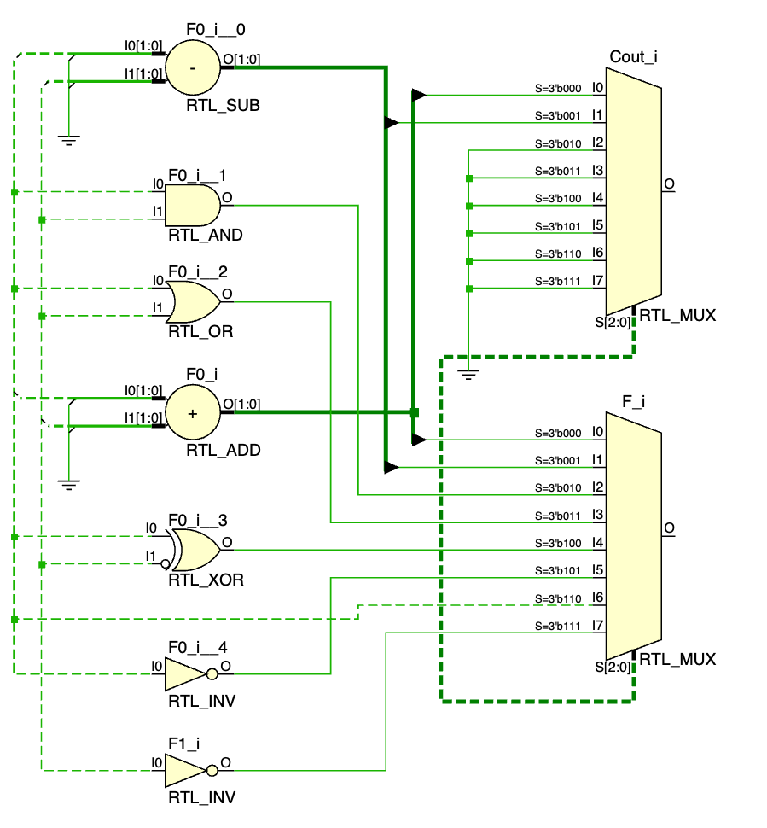

(d) ModelSim源程序
文件：lab1/task4/sim/tb_alu_1bit.v

`timescale 1ns / 1ps
// Self-checking testbench for 任务4：1 位 ALU 电路.
module tb_alu_1bit;
reg A;
reg B;
reg [2:0] S;
wire F;
wire Cout;
integer ai;
integer bi;
integer si;
integer error_count;
reg expected_f;
reg expected_cout;
alu_1bit uut (
.A(A),
.B(B),
.S(S),
.F(F),
.Cout(Cout)
);
task expected_for;
input a_in;
input b_in;
input [2:0] s_in;
output f_out;
output cout_out;
begin
f_out = 1'b0;
cout_out = 1'b0;
case (s_in)
3'b000: {cout_out, f_out} = {1'b0, a_in} + {1'b0, b_in};
3'b001: {cout_out, f_out} = {1'b0, a_in} - {1'b0, b_in};
3'b010: f_out = a_in & b_in;
3'b011: f_out = a_in | b_in;
3'b100: f_out = a_in ^ (~b_in);
3'b101: f_out = ~a_in;
3'b110: f_out = a_in;
3'b111: f_out = ~b_in;
default: begin
f_out = 1'b0;
cout_out = 1'b0;
end
endcase
end
endtask
task check_result;
input exp_f;
input exp_cout;
begin
#1;
if (F !== exp_f || Cout !== exp_cout) begin
$display("ERROR time=%0t A=%b B=%b S=%b F=%b Cout=%b expected F=%b Cout=%b",
$time, A, B, S, F, Cout, exp_f, exp_cout);
error_count = error_count + 1;
end else begin
$display("PASS time=%0t A=%b B=%b S=%b F=%b Cout=%b",
$time, A, B, S, F, Cout);
end
end
endtask
initial begin
error_count = 0;
for (si = 0; si < 8; si = si + 1) begin
for (ai = 0; ai < 2; ai = ai + 1) begin
for (bi = 0; bi < 2; bi = bi + 1) begin
S = si[2:0];
A = ai[0];
B = bi[0];
expected_for(A, B, S, expected_f, expected_cout);
#10; check_result(expected_f, expected_cout);
end
end
end
if (error_count == 0) begin
$display("========================================");
$display("Simulation PASSED. No errors found.");
$display("========================================");
end else begin
$display("========================================");
$display("Simulation FAILED. Error count = %0d", error_count);
$display("========================================");
end
$finish;
end
endmodule
仿真脚本：lab1/task4/sim/run.do
transcript on
onbreak {resume}
onerror {quit -code 1}
set sim_dir [file normalize [pwd]]
set root_dir [file normalize [file join $sim_dir ".."]]
set top_module "alu_1bit"
set sim_top "tb_alu_1bit"
cd $sim_dir
if {[file exists work]} {
vdel -lib work -all
}
vlib work
vmap work work
set src_files [lsort [glob -nocomplain [file join $root_dir "src" "*.v"]]]
set tb_files [lsort [glob -nocomplain [file join $sim_dir "*.v"]]]
if {[llength $src_files] == 0} {
puts "ERROR: No RTL source files found in [file join $root_dir src]"
quit -code 1
}
if {[llength $tb_files] == 0} {
puts "ERROR: No testbench files found in $sim_dir"
quit -code 1
}
puts "========================================"
puts "Compile RTL sources"
puts "========================================"
foreach file $src_files {
puts "vlog $file"
vlog -work work $file
}
puts "========================================"
puts "Compile simulation sources"
puts "========================================"
foreach file $tb_files {
puts "vlog $file"
vlog -work work $file
}
puts "========================================"
puts "Start simulation: work.$sim_top"
puts "========================================"
vsim -voptargs=+acc work.$sim_top
onfinish stop
if {[batch_mode]} {
log -r /*
} elseif {[file exists [file join $sim_dir "wave.do"]]} {
do [file join $sim_dir "wave.do"]
} else {
log -r /*
add wave -r /*
}
run -all
set error_count_value ""
if {![catch {examine -radix decimal /$sim_top/error_count} error_count_value]} {
puts "Self-check error_count = $error_count_value"
if {$error_count_value != 0} {
puts "ERROR: Self-checking testbench reported failures."
quit -code 1
}
}
puts "========================================"
puts "ModelSim flow finished."
puts "Top module: $top_module"
puts "Simulation top: $sim_top"
puts "========================================"
(e) ModelSim仿真结果

五、实验过程中出现的故障现象、原因分析及解决的办法
组合逻辑任务中容易混淆74LS138和74LS148的低有效输入/输出语义。解决办法是在testbench中直接按芯片真值语义构造期望值，先覆盖禁止态，再覆盖有效态。
4位加法器验证若只测试少量样例，可能漏掉进位传播边界。解决办法是穷举全部输入组合，并以5位期望和比较{cout,sum}。

